

*[Geophysical Research Letters]*

Supporting Information for

**Line of Sight Displacement from ALOS-2 Interferometry: M7.8 Gorkha Earthquake and Mw 7.3 Aftershock**

Eric O. Lindsey1

Ryo Natsuaki2

Xiaohua Xu1

Masanobu Shimada2

Manabu, Hashimoto3

Diego Melgar4

David T. Sandwell1

1Institute for Geophysics and Planetary Physics, University of California, San Diego, USA

2Earth Observation Research Center, Japan Aerospace Exploration Agency (JAXA), Tskuba, Japan

3Disaster Prevention Research Institute, Kyoto University, Kyoto, Japan

4Seismological Laboratory, UC Berkeley, Berkeley, USA

**Contents of this file**

Text S1

Figures S1 to S3

Tables S1 and S2

**Introduction**

In this supplement, the inverse method is described in greater detail (Text S1) and is supported by three figures. Two tables describe the key parameters required for burst alignment and list our observations of burst offsets during the period prior to February 8, 2015.

Figure S1 shows the distribution of data in each of the four interferograms used for modeling after downsampling, and shows the residuals for the best-fitting model shown in figure 2d. Figure S2 shows the effect of considering only one of the two coseismic interferograms in the model; the fact that the two results are highly similar gives us confidence that the model is well-resolved by the data. Figure S3 considers the effect of varying the regularization parameter on the model, showing variations in the slip roughness and peak slip depending on how this parameter is chosen.

Table S1 contains the operation parameters for ALOS-2 ScanSAR (WD1) mode that are required for computing the burst offsets reported in Tables A1 and S2. The near range and pulse repetition frequency (PRF) for subswaths F1-5 are found in the metadata provided by the Japanese Aerospace Exploration Agency (JAXA) with L1.1 data products. The values of nburst represent the number of pulses per burst. Incidence angles in degrees for each subswath are approximate and computed from the satellite observation geometry.

Table S2 reports measured burst offsets for each subswath for 34 pre-February 8, 2015 WD1 mode acquisitions, relative to acquisitions made after February 8, 2015. Data are from ten different paths/frames distributed worldwide. The values for subswath 1 are plotted in Figure A1 and were used to compute the best-fitting parameters for equation A1.

**Text S1.**

Inverse method description: We use the main nodal plane from the USGS W-phase moment tensor solution as the dislocation surface for the inversion. This has a strike of 295° and dip of 11°, this surface is sued for both the mainshock and aftershock inversion. The assumed fault was discretized into 300 10x10 km subfaults for the mainshock inversion and 255 5x5km subfaults for the aftershock inversion. Ascending and descending unwrapped line of sight measurements are downsampled using the QuadTree technique [Lohman & Simons, 2005]. (Figure S1). Elastostatic Green’s functions for each downsampled point to subfault pair are computed using the frequency wavenumber integration technique of Zhu and Rivera [2002]. We invert the descending and ascending tracks both separately and jointly to test the resolution of the model and the persistence of the observed slip features (Figure S2). The inversion is carried out using non-negative least squares and the rake is constrained to values between 45 and 135. Spatial regularization was achieved though minimum norm smoothing; constraints were placed on the L2 norm of the model parameter vector. We test the effect of varying the strength of the spatial smoothing, the results are shown in Figure S3. They indicate that the observed slip gap is a persistent feature irrespective of the level of smoothing used. It’s important to note that unlike Laplacian smoothing sometimes used in inversions, the minimum norm smoothing used here does not force spatial smoothness. The observed smoothness of slip is introduced by the data itself.

figureS1

Figure S1. Data downsampling and residuals for data used in the model results shown in figure 2d. Panels show: (a) M7.8 mainshock residuals for Path 48, (b) mainshock residuals for Path 157, (c) M7.3 aftershock residuals for Path 48, and (d) aftershock residuals for Path 156. Nonzero residuals may indicate areas where the fault deviates from our assumed planar geometry; the role of model regularization is explored in Figure S2.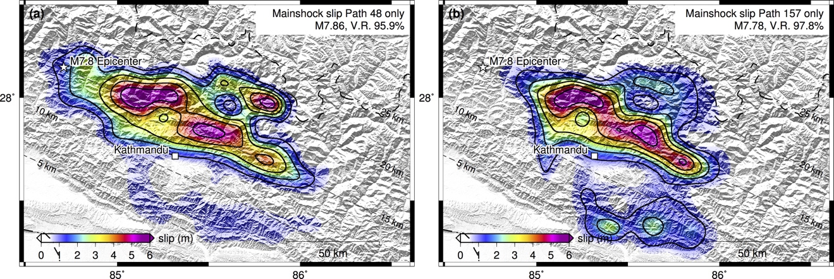

Figure S2. Model results considering only data from Path 48 (a) and Path 157 (b). Models are visually similar, but slip is confined to the area of data coverage for Path 157, highlighting the value of the complete spatial coverage of Path 48. Shallow slip above 10km is preferred by the Path 157 data; whether this slip is truly required by the data is explored in figure S3.

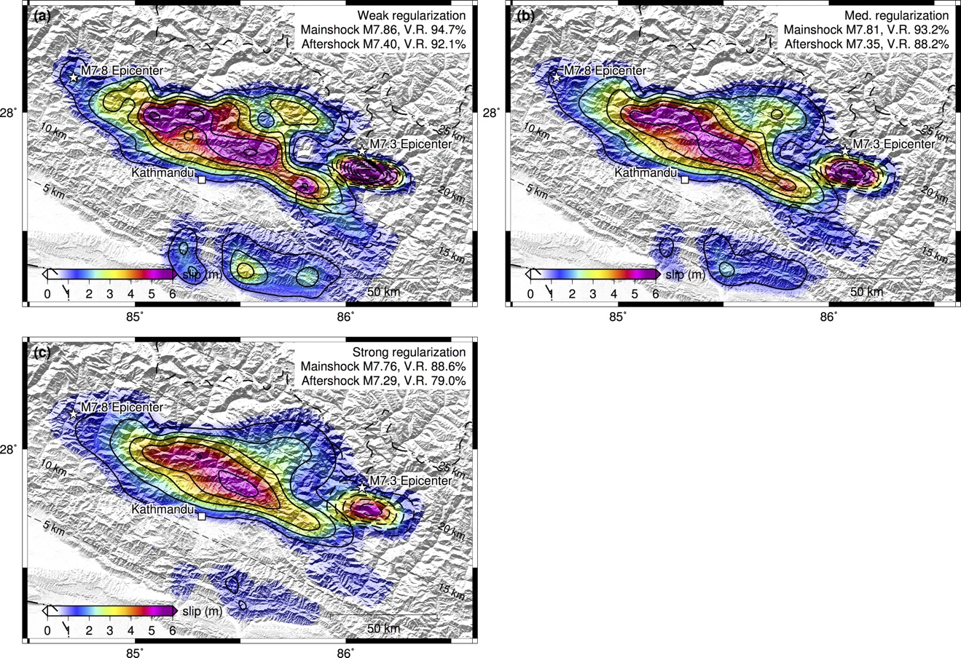

Figure S3. Model results showing the effect of varying regularization strength. (a) Weak regularization, (b) medium regularization (same as Figure 2d in the main text), (c) strong regularization. Solid lines show contours of mainshock slip; aftershock slip contours are dashed. Some shallow slip above 10km is preferred but not strongly required by the data, but the ‘gap’ of low slip between the mainshock and aftershock appears to be well-resolved and is present in all models. Peak slip varies between 5.5 – 6.5 m for the mainshock and between 5.5 – 10 m for the aftershock, depending on the choice of regularization.

|  |  |  |  |  |  |
| --- | --- | --- | --- | --- | --- |
|  | F1 | F2 | F3 | F4 | F5 |
| Near range (m) | 696038 | 733527 | 768724 | 814228 | 860505 |
| PRF (Hz) | 2662.8 | 3314.5 | 2406.6 | 2270.6 | 2821.2 |
| Nburst (pixel) | 420 | 522 | 379 | 358 | 445 |
| Incidence (deg.) | 27 | 33 | 38 | 44 | 49 |

Table S1. ALOS-2 ScanSAR (WD1) mode characteristics. F1 through F5 denote subswaths in the increasing range direction. PRF is the pulse repetition frequency, and nburst is the number of pulses per burst for each subswath.

|  |  |  |  |  |  |  |  |
| --- | --- | --- | --- | --- | --- | --- | --- |
| Date_pre | Date_post | Obs. Location | F1 | F2 | F3 | F4 | F5 |
| 7/24/2014 | 3/19/2015 | Hokkaido | 76 | 86 | 63 | 59 | 61 |
| 8/2/2014 | 2/28/2015 | Philippine_P24 | -290 | -374 | -271 | -257 | -317 |
| 8/8/2014 | 2/20/2015 | NapaP168 | -645 | -787 | -584 | -555 | -704 |
| 8/13/2014 | 2/25/2015 | NapaP169 | -841 | -1030 | -759 | -723 | -904 |
| 9/3/2014 | 2/18/2015 | Croatia | 702 | 875 | 634 | 599 | 744 |
| 9/4/2014 | 2/19/2015 | Philippine_P25 | 740 | 890 | 840 | 640 | 820 |
| 9/5/2014 | 2/20/2015 | NapaP168 | 655 | 817 | 594 | 560 | 697 |
| 9/10/2014 | 2/25/2015 | NapaP169 | 615 | 766 | 558 | 527 | 654 |
| 9/11/2014 | 2/26/2015 | Gabon | 643 | 771 | 586 | 568 | 725 |
| 9/13/2014 | 2/28/2015 | Philippine_P24 | 649 | 768 | 583 | 565 | 718 |
| 10/15/2014 | 2/18/2015 | Croatia | 903 | 1126 | 818 | 771 | 960 |
| 10/16/2014 | 2/19/2015 | Philippine_P25 | 930 | 1160 | 840 | 790 | 990 |
| 10/16/2014 | 3/19/2015 | Hokkaido | 900 | 1108 | 809 | 776 | 967 |
| 10/23/2014 | 2/26/2015 | Gabon | -935 | -1162 | -841 | -793 | -983 |
| 10/25/2014 | 2/28/2015 | Philippine_P24 | -859 | -1096 | -782 | -728 | -895 |
| 10/30/2014 | 3/19/2015 | Hokkaido | -734 | -911 | -666 | -623 | -783 |
| 11/13/2014 | 3/19/2015 | Hokkaido | -90 | -119 | -85 | -82 | -113 |
| 11/26/2014 | 2/18/2015 | Croatia | 654 | 814 | 591 | 560 | 696 |
| 11/27/2014 | 2/19/2015 | Philippine_P25 | 690 | 860 | 625 | 590 | 730 |
| 11/27/2014 | 2/19/2015 | Antarctica | 690 | 862 | 625 | 589 | 715 |
| 11/28/2014 | 2/20/2015 | NapaP168 | 778 | 969 | 704 | 665 | 825 |
| 12/3/2014 | 2/25/2015 | NapaP169 | -1011 | -1240 | -913 | -868 | -1088 |
| 12/4/2014 | 2/26/2015 | Gabon | -949 | -1177 | -855 | -804 | -998 |
| 12/6/2014 | 2/28/2015 | Philippine_P24 | -859 | -1051 | -773 | -741 | -922 |
| 12/11/2014 | 2/19/2015 | Antarctica | -569 | -707 | -517 | -489 | -583 |
| 12/25/2014 | 2/19/2015 | Antarctica | 335 | 419 | 302 | 284 | 357 |
| 1/7/2015 | 2/18/2015 | Croatia | -955 | -1173 | -863 | -822 | -1030 |
| 1/8/2015 | 2/19/2015 | Philippine_P25 | -910 | -1120 | -825 | -790 | -985 |
| 1/8/2015 | 2/19/2015 | Antarctica | -885 | -1102 | -801 | -756 | -908 |
| 1/9/2015 | 2/20/2015 | NapaP168 | -840 | -1027 | -762 | -725 | -911 |
| 1/14/2015 | 2/25/2015 | NapaP169 | -538 | -653 | -487 | -467 | -602 |
| 1/15/2015 | 2/26/2015 | Gabon | -475 | -475 | -428 | -404 | -502 |
| 1/22/2015 | 2/19/2015 | Antarctica | -101 | -127 | -92 | -85 | -94 |
| 2/5/2015 | 2/19/2015 | Antarctica | 600 | 750 | 600 | 510 | 626 |

Table S2. Burst offsets for data collected prior to February 8, 2015 (dates in column 1), computed in pixels relative to data collected after that date (column 2). Values are computed for ten different Paths/frames distributed worldwide (column 3). Values for subswath 1 (column 4) are plotted as circles in Figure A1.